**A REPORT ON HOSPITAL TRAINING**

***Undergone at***

**SRI VENKATESHWARA INSTITUTE OF MEDICAL SCIENCES*,* TIRUPATHI.**

***Submitted by***

**PARINITHA.K (170301071)**

***In partial fulfilment of the requirements for the award of the degree of***

**BACHELOR OF ENGINEERING**

***In***

**BIOMEDICAL ENGINEERING**



**RAJALAKSHMI ENGINEERING COLLEGE : CHENNAI -602 105**



**ANNA UNIVERSITY : CHENNAI -600 025**

**NOVEMBER 2020**

**DEPARTMENT OF BIOMEDICAL ENGINEERING**

**RAJALAKSHMI ENGINEERING COLLEGE**

**CHENNAI – 602 105**

**BONAFIDE CERTIFICATE**

It is certified that **HOSPITAL TRAINING REPORT** is the Bonafide work of **“PARINITHA.K (170301071)”** who underwent hospital training in **SRI VENKATESHWARA INSTITUTE OF MEDICAL SCIENCES, TIRUPATHI**, during 22th  November – 08th December – 2018. This report is prepared and submitted by the above students for **BM17712-HOSPITAL TRAINING.**

**SIGNATURE SIGNATURE**

Submitted for the Hospital Training viva-voice held on ______________ at Rajalakshmi Engineering College, Thandalam.

**Internal Examiner External Examiner**

**ACKNOWLEDGEMENT**

We express our gratitude to all who have helped us in the training work. We would like to place our sincere thanks to our chairman **Mr.S.Megnathan** and our chairperson **Dr.Mrs.Thangam Meganathan**. We wish to express our intense sense of idolization and affluence to our Principal **Dr.S.N.Murugesan.**

We would like to express our sense of gratitude to our head of the department **Dr.S.Rajkumar,** and our hospital training coordinators **Ms.Sudha S** Assistance Professor.We would like to extend our sense of gratitude to our faculty advisors and staffs of **SRI VENKATESHWARA INSTITUTE OF MEDICAL SCIENCES** who gave us valuable suggestions during training period. It is our pleasure to extend our gratefulness to all our faculty members, without whom this Hospital Training would be a distant reality.

**ABOUT THE HOSPITAL:**

Sri Venkateswara Institute of Medical Sciences (SVIMS) is a Medical [Institute under State Legislature Act](https://en.wikipedia.org/wiki/Institute_under_State_Legislature_Act) and a speciality hospital in [Tirupati](https://en.wikipedia.org/wiki/Tirupati), [Andhra Pradesh](https://en.wikipedia.org/wiki/Andhra_Pradesh), [India](https://en.wikipedia.org/wiki/India). SVIMS was conceived on the lines of [All India Institute of Medical Sciences Delhi](https://en.wikipedia.org/wiki/All_India_Institute_of_Medical_Sciences_Delhi), and was created by an act of the Andhra Pradesh State Legislature. The [foundation stone](https://en.wikipedia.org/wiki/Foundation_stone) was laid on 18 April 1986 by [N. T. Rama Rao](https://en.wikipedia.org/wiki/N._T._Rama_Rao), the then Chief Minister of Andhra Pradesh. The hospital started functioning from 2 February 1993 and later became a Medical [Institute under State Legislature Act](https://en.wikipedia.org/wiki/Institute_under_State_Legislature_Act) in 1995. The current Director is Dr B Vengamma .

All the programmes of the institute are approved by the Medical Council of India (MCI). The institute is spread over an area of 107.04 acres.

The college provides undergraduate, postgraduate, diploma and doctoral programmes on various disciplines which includes MBBS, MD, DM, MCh, B.Sc., M.Sc., PG Diploma and Ph.D.

The [National Institutional Ranking Framework](https://en.wikipedia.org/wiki/National_Institutional_Ranking_Framework) (NIRF) ranked Sri Venkateswara Institute of Medical Sciences 72 overall in India[[3]](https://en.wikipedia.org/wiki/Sri_Venkateswara_Institute_of_Medical_Sciences#cite_note-3) in 2019, 77 among universities and 29th in the medical ranking.

Sri Venkateswara Institute of Medical Sciences offers postgraduate courses in almost all super specialty subjects including surgery, medicine, etc. Similarly it offers a variety of Doctoral courses including [Neurosurgery](https://en.wikipedia.org/wiki/Neurosurgery), [Cardiac Surgery](https://en.wikipedia.org/wiki/Cardiac_surgery) among others and [DM](https://en.wikipedia.org/wiki/Doctorate_of_Medicine) in [Cardiology](https://en.wikipedia.org/wiki/Cardiology), [Neurology](https://en.wikipedia.org/wiki/Neurology) etc. There are more than 28 post graduate and post doctoral courses.

**TABLE OF CONTENT**

**CHAPTER TITLE PAGE**

**ACKNOWLEDGEMENT 3**

**ABOUT THE INDUSTRY 4**

**OUTCOME OF THE TRAINING 49**

**INTERNSHIP CERTIFICATE 50**

**1 INTRODUCTION 8**

1.1 FUNCTIONS OF BIOMEDICAL DEPARTMENT 8

1.2 TYPES OF EQUIPMENTS: 9

1.3 PLANNED PREVENTIVE MAINTENANCE: 9

**2 DEPARTMENTS IN THE HOSPITALS 10**

2.1 ANEASTHETICS 10

2.2 CARDIOLOGY 12

2.3 MEDICAL ONCOLOGY 17

2.4 PSYCHIATRY 18

2.5 DERMATOLOGY 18

2.6 NUCLEAR MEDICINE 18

2.7 CRITICAL CARE 20

2.8 GENERAL SURGERY 24

2.9 GYNAECOLOGY 25

2.10 PAEDIATRICS 27

2.11 NEUROLOGY 29

2.12 OPTHALMOLOGY 33

2.13 BIOCHEMISTRY LAB 34

2.14 OPERATION THEATRE (O.T) 37

2.15 RADIOLOGY 44

2.16 PHYSIOTHERAPY 48

**LIST OF FIGURES**

1.Fig. :Anaesthesia machine

*(PC-https://www.indiamart.com/proddetail/fabius-plus-anaesthesia-workstation-4027079712.html)*

2.Fig. :Ultrasound

*(PC- https://www.nationalultrasound.com/products/siemens-acuson-sc2000-ultrasound-machine/)*

3.Fig. :Echo Cardiogram

*(PC-https://www.providianmedical.com/ultrasound-machines/philips/philips-sonos-7500/)*

4.Fig. : Defibrillator

*(PC-://www.indiamart.com/eliteplus/automatic-external-defibrillators.html)*

5.Fig. :Aerial blood gas analyser

*(PC-https://www.hilditchgroup.com/en/Lots/LotDetails/a80a5cd1-e2c7-aa42-95ac-6a2da4b5bcf7)*

6.Fig. : Ventilator

*(PC-https://www.indiamart.com/proddetail/covidien-puritan-bennett-840-icu-medical-ventilator-pb-840-20621267048.html)*

7.Fig. : Syringe pump

*(PC-https://www.dotmed.com/listing/pump-iv-infusion/terumo/331-syringe-pump/1169067)*

8.Fig. : Infusion pump:

*(PC- http://infusionpumpprice.blogspot.com/2016/05/infusion-pump-terumo-te-112-made-in.html)*

9.Fig. : Multipara monitor:

*(PC-https://www.medicalexpo.com/prod/philips-healthcare/product-70721-625087.html)*

10.Fig. :Fetal Monitor

*(PC-https://www.indiamart.com/proddetail/f1-ultra-fetal-monitor-19218515433.html)*

11.Fig. :OB/GYN Table

*(PC:https://www.tigermedical.com/Products/OB-GYN-Exam-Table__CLI8870OBGYN.aspx)*

12.Fig. : Cardiotoco Meter

*(PC-http://www.huntleigh-diagnostics.com/store/obstetric-monitoring/sonicaid-fetal-monitoring/fetal-monitors/sonicaid-bd4000xs-fetal-monitoring)*

13.Fig. :Infant Warmer

*(PC-https://www.indiamart.com/proddetail/phoenix-cic-101-radiant-heat-warmer-19924387130.html)*

14.Fig. : EEG-*(PC-https://www.medwrench.com/equipment/2250/medelec-teca-emg-ep-plinth-system-n)*

15.Fig. : EMG-*(PC-https://neuro.natus.com/products-services/electromyography-emg-solutions)*

16.Fig. :Diathermy Machine

*(PC- https://auctions.britishmedicalauctions.co.uk/lot-details)*

17.Fig. : Coagulation analyser

*(PC-https://www.medicalexpo.com/prod/awareness-technology/product-67695-431575.html)*

18Fig. : Auto analyser:

*(PC-https://www.bidspotter.com/en-us/auction-catalogues/bscsal/catalogue-id-bscsal10021/lot-5a543249-9a70-4eda-9e77-a3c500ea62ac)*

19.Fig. 12: Biorefrigrator

*(PC-https://www.indiamart.com/proddetail/lab-refrigerator-bio-ultra-21885448791.html)*

20.Fig. : Microscope

*(PC-https://www.indiamart.com/proddetail/nikon-microscope-e-200-16513468530.html)*

21.Fig. : OT Light

*(PC-http://www.medwow.com/med/surgical-light/berchtold/chromophare-c-572/17649.model-spec)*

22.Fig. : X-RAY

*(PC-https://www.indiamart.com/proddetail/800ma-x-ray-machine-14338185391.html)*

**1.INTRODUCTION:**

The team offers effective assistance in ensuring a good working condition for

different equipment in the hospital. The teams work around the clock to assist

breakdown / failure of equipment in emergency response support. In the various

specialties of the hospital, the department  ensures the quality service of all

categories of  equipment. In order to  facilitate smooth and  full patient

treatment, the biomedical  engineering department  plays an important role.

**1.1FUNCTIONS OF BIOMEDICAL DEPARTMENT IN A HOSPITAL:**

* Analyse and compare technical specifications of equipments.
* Evaluate initial cost and operating cost of equipments before procurement.
* Inspect incoming equipments and perform pre–acceptance checks before equipment is officially accepted and payment is done to the vendor.
* Set standard operating and regular maintenance guidelines and ensure their compliance.
* Provide training for user department to ensure proper use of equipment.
* Evaluate the need for new equipment or replacement of existing equipment.
* Provide technical advice and expertise to administration, medical and paramedical staff.
* Organizing a planned maintenance program for all equipment and attend to regular or emergency breakdown and repair of equipments.
* Instituting an effective equipment control system.
* Maintain work record and maintenance history record.
* Establish an inventory of all existing and incoming equipment.
* Active involvement in the hospital’s safety committee and checking safety hazards.

**1.2TYPES OF EQUIPMENTS:**

|  |  |  |
| --- | --- | --- |
| **Critical** | **Semi critical** | **Non critical** |
| The equipments which are directly contact with the patient are called critical equipments. | They are contact with the patient but does not cause much harmful to patient. | They are not directly contact with the patient. |
| Example:  Defibrilator  Ventilator  Dialysis  Heart lung machine  Anesthetic machine | Example:  Endoscope  Laryngoscope | Example:  BP apparatus  Pulse oxymeter |
| The PM should be done in every 3 months | The PM should be done in every 6 months | The PM should be done in every 12 months |

**1.3PLANNED PREVENTIVE MAINTENANCE:**

* PPM is usually scheduled at specific intervals and includes specific maintenance activities such as lubrication, calibration, cleaning of filters or replacement of spare parts that are expected to wear out after stipulated time or workload (e.g. bearings, tubings).
* Effective planning for preventive maintenance will involve careful selection of the equipment to be included in the plan
* Maintenance planning shall always ensure that essential medical equipment for basic diagnosis, infection control, surgery and treatment are kept in good working condition.

**2. FOLLOWING ARE THE DEPARTMENTS IN THE HOSPITAL:**

**2.1 ANEASTHETICS:**

The department is having all the latest state - of - art equipment relating to Anaesthesia and Critical Care Medicine. Clinical work load covers administration of anaesthesia and perioperative care to six super surgical specialty and four broad surgical specialty services apart from anaesthesia support for remote location that includes radiology suite, catheterization lab and electroconvulsive therapy. The department also runs a 15 bedded state of the art respiratory intensive care unit (RICU) with round the clock service for resuscitation and ventilator management.

The Anaesthetic team provide anaesthesia to allow patients to tolerate operations and procedures in comfort and safety. This may be a local anaesthetic where the patient may remain awake, a local anaesthetic with sedation to make the patient drowsy or a full general anaesthetic where the patient will be asleep.

Anaesthetists work alongside surgical teams in the main and day surgery theatres, providing anaesthetic support for women in labour and with the help of an acute pain team, provide pain relief to patients who need it after an operation.

The department also provides anaesthetic staff to the intensive care unit and a specialist outreach team helps medical staff with the care of sicker patients on the wards.

**Equipments:**

|  |  |  |
| --- | --- | --- |
|  | | |
| **S.no.** | **Name of the Instrument** | **Quantity** |
| **1.** | Jet Ventilator | 01 |
| **2.** | Boyls Ultima | 01 |
| **3.** | Ambu Man Model IC for CPR | 01 |
| **4.** | Intubation Trainer | 01 |
| **5.** | Medumat Electonics portable ventilator | 01 |
| **6.** | Pheripheral nerve stimulator | 01 |
| **7.** | Intellive MP60 Monitor | 11 |
| **8.** | Anaesthesia work station  ( Aestiva Datex – OHMEDA) | 03 |
| **9.** | Drager Faibius plus Anaesthesia Workstation | 09 |
| **10.** | Edward Vigileo Monitor | 01 |
| **11.** | Ambu Bag Adult | 08 |
| **12.** | Ambu Bag Pediatric | 08 |
| **13.** | BP Apparatus ( Digital) with Cuff of Arm | 03 |
| **14.** | Flexible Video  Endoscope  5.5mm with Monitor | 01 |
| **15.** | Flexible Intubation video endoscope 4.0mm with monitor | 01 |
| **16.** | Video Laryngoscope (Carl Storz) | 04 |
| **S.no.** | **Name of the Instrument** | **Quantity** |
| **01.** | ICU Ventilator | 04 |
| **02.** | Multichannel Monitors G3G | 18 |
| **03.** | Allied Jupiter Plus work stations | 6 |
| **04.** | B.Braun Syringe Pumps | 2 |
| **05.** | Infusion Pump | 10 |
| **Respiratory Intensive Care Unit** | | |
| **S.no.** | **Name of the Instrument** | **Quantity** |
| **1.** | Maquet & Engstrom (GE) Ventilators | 15 (10+5) |
| **2.** | Mobile Monitors | 3 |
| **3.** | Dum Light  ( Big) | 1 |
| **4.** | Suction Apparatus | 1 |
| **5.** | Syringe Pumps | 20 |
| **6.** | ABG Machine | 1 |
| **7.** | Multichannel Monitors | 17 |
| **8.** | Mechanical Thrombo Prophyaxis device | 2 |

**Anaesthesia machine:**

**Function:**

The most common type of anaesthetic machine is the continuous-flow anaesthetic machine, which is designed to provide an accurate and continuous supply of medical gases (O2,N2O) mixed with an accurate concentration of anaesthetic vapour (halothane or isoflurane), and deliver this to the patient at a safe pressure and flow. Modern machines incorporate a ventilator, suction unit, and patient monitoring devices.

Manufacturer: **Drager Fabius plus Anaesthesia Workstation**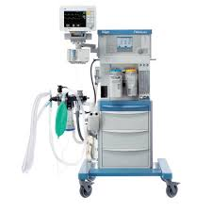

1.Fig. :Anaesthesia machine

*(PC-https://www.indiamart.com/proddetail/fabius-plus-anaesthesia-workstation-4027079712.html)*

**Principle:**

O2, N2O and sometimes air sources are connected to the machine. Through gas flowmeters , a controlled mixture of these gases along with anaesthetic vapour passes through a vaporizer and is delivered to the patient. Sometimes a ventilator is also connected with the machine for rebreathing thus making it a closed circuit. With ventilators or a re-breathing patient circuit, soda lime canisters are used to absorb the exhaled carbon dioxide and fresh gases are added to the circuit for reuse

**Troubleshooting:**

* leakage of air
* O2 failure alarm not working

**2.2CARDIOLOGY:**

The department of cardiology provides a full range of services for inpatients &outpatients. Our specialist cardiovascular centre treats problems of the heart & blood vessels.

Cardiac conditions they treat include:

                 1. Spectrum of coronary artery disease

                 2. Arrhythmias

                 3. Heart failure

                 4. Congenital heart disease

                 5. Valvular heart disease

                 6. DVT and Pulmonary thromboembolism

                 7. Peripheral vascular diseases

                 8. Pericardial diseases

The services provided:

1. Outpatient services

2. Inpatient services (ICCU, SDICU & general wards)

3. Consultation services

4. Cardiac catheterization

5. Electrophysiology services

6. Peripheral vascular interventions

7. Non invasive imaging and investigations

8. Preventive cardiology

**EQUIPMENTS**

Cardiac Catheterization Laboratory :

* Philips AluraXper FD 10c Flat panel digital Cardiac Catheterization Lab
* Siemens Artis flat panel digital Cardiac Catheterization Lab

ICCU:

* PHILIPS intellivue MP 20 with central monitor – 8 nos
* Mindray Bone view T8 – 6 nos

ECHO LAB

* Siemens Acuson SC2000- 1, Paediatric and adult TEE probes -2
* Philips iE33 Echo machine with 3D, Linear adult, Paediatric and Multiplane TEE probes -- 1
* PHILIPS Sonos 7500 with multiple TEE probe -- 1
* PHILIPS Sonos 4500 -- 1
* eSaote MyLab40 – 2 nos

ECG:

* Mortara instruments (ELI 250) – 5
* GE Mac 1200 – 1
* TMT LAB:
* RMS Cardio Tread Mill – 1
* GE T2100 (Vintron) TMT – 1
* HOLTER:
* DELMAR Reynolds Monitor with 3 sets of Cables
* Ambulatory Blood Pressure machines:
* MediTech ABPM-05 – 1
* CardioPerfect – 1

FFR:

* QUANTIEN (St. Jude) – 1

IVUS:

* I LAB Ultrasound imaging system (Boston on scientific) – 1

ROTABLATOR:

* Boston scientific – 1

Other Equipments:

* TPI Pulse Generator   - 4 nos
* Defibrillators               - 6 nos
* Roche Quantitative Troponin-T, BNP, D-dimer analyzer  -- 1
* Terumo Penpol DF 40U Programmable Deep Freezer – 1
* Datascope IABP machine
* AggreGuide A-100 [Aggredyne] Platelet Aggregometer -- 1
* Radiometer AQT90 FLEX for Troponin-T, Troponin-I, CRP, D-dimer, NT-proBNP -- 2

**Ultrasound And Echo Cardiogram:**

The transducer probe is the main part of the ultrasound machine.

* The transducer probe makes the sound waves and receives the echoes.
* The transducer probe generates and receives sound waves using a principle called the piezoelectric (pressure electricity) effect.

DOPPLER principle is used in this machine.

The main difference between ultrasound and an echo cardiogram is that ultrasound is for imaging stable organs whereas echo is for moving organs(heart).

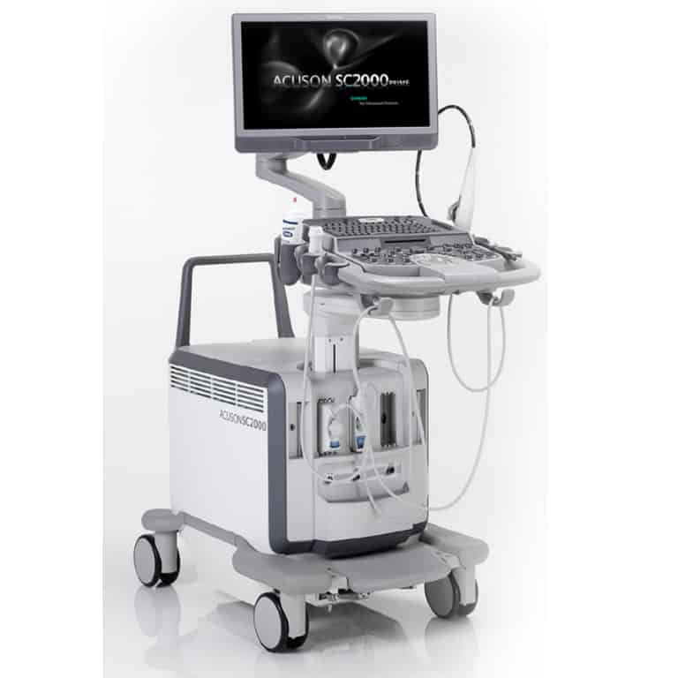

2.Fig. :Ultrasound

*(PC- https://www.nationalultrasound.com/products/siemens-acuson-sc2000-ultrasound-machine/)*

# MAKE : Siemens Ultrasound Machine

MODEL: Acuson SC2000 Prime

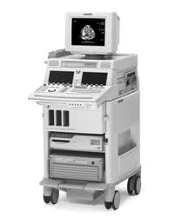

3.Fig. :Echo Cardiogram

*(PC-https://www.providianmedical.com/ultrasound-machines/philips/philips-sonos-7500/)*

MAKE : **PHILIPS**;

MODEL: **Sonos 7500 with multiple TEE probe – 1**

**Defibrillator:**

Defibrillator delivers a dose of electric current (often called a countershock) to the heart

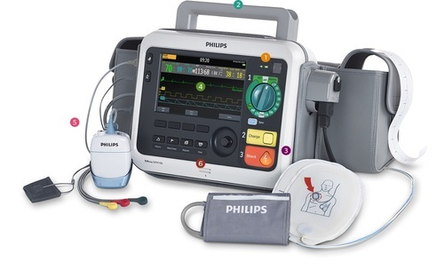

4.Fig. : Defibrillator

*(PC-://www.indiamart.com/eliteplus/automatic-external-defibrillators.html)*

Manufacturer : **philips heart start xc**

Modes:

AED mode(sensor enabled),AED mode(sensor disabled),manual mode

Mechanical components:

* Display/motherboard
* Shock delivery capacitors
* Power board
* Ecg,spo2 sensors, shock pads.

**2.3 MEDICAL ONCOLOGY**

The Department of Medical Oncology offers comprehensive cancer care and is responsible for diagnosing and treating all cases of solid tumours and hematological malignancies.  Medical oncology is the subspecialty of oncology which deals with the medical management of cancer. It treats cancer with anticancer drugs -chemotherapy, hormonal therapy, targeted therapy, immunotherapy, etc. The Medical Oncologist determines the proper choice of drugs, dosage, and schedule of the drug regimen to be given.

**Cancer Biology**

Cancer encompasses many organ systems and their complications.  Cancer is a term used for diseases in which abnormal cells divide without control and are able to invade adjacent and other tissues. Normally, cells grow and divide to produce more cells only when the body needs them. Sometimes, however, cells become abnormal and keep dividing to form more cells without control or order, creating a mass of excess tissue called a tumor. Tumors can be malignant (cancerous) or benign (not cancerous). The cells in malignant tumors can invade and damage nearby and distant tissues and organs. Cancer cells can also break away from a malignant tumor and travel through the bloodstream or lymphatic system to form new tumors in other parts of the body.

**Equipment**

|  |  |  |
| --- | --- | --- |
| **S.NO** | **EQUIPMENT NAME** | **QTY(NOS)** |
| 1 | MINRE MONITORS | 04 |
| 2 | ASPEN PULSE OXYMETER | 01 |
| 3 | BCI  PULSE OXYMETER | 01 |
| 4 | VENTILATOR | 01 |
| 5 | LAMINAR AIR FLOW | 03 |
| 6 | DE FIBRILATOR | 01 |
| 7 | NEBULIZER | 01 |
| 8 | ELECTRICAL WEIGHING MACHINE | 01 |

**2.4 PSYCHIATRY**

This Department provides out-patient services and inpatient services on all working days of the hospital. The department actively participates in various patient and academic related activities. We provide referral services to all broad and super-speciality wards in the hospital.

**Equipment**

1. Brief pulse electroconvulsive therapy machine (NIVIQURE)- Technology developed in conjunction with NIMHANS.
2. Transcranial Direct Current Stimulation (tDCS) – Active Dose II

**2.5 DERMATOLOGY**

Dermatology is the branch of medicine dealing with the skin. It is a speciality with both medical and surgical aspects. A dermatologist is a specialist doctor who manages diseases related to skin, hair and nails and some cosmetic problems

Equipment

1. Radio surgical Unit – DERMAINDIA

**2.6 NUCLEAR MEDICINE**

Department has started functioning in a small area with a Single Head Gamma Camera with One Faculty and One Technologist and  started growing year after year by leaps and bounds by expanding with PET-CT Unit and High Dose Radionuclide Therapy facility.

**Equipments & Services**

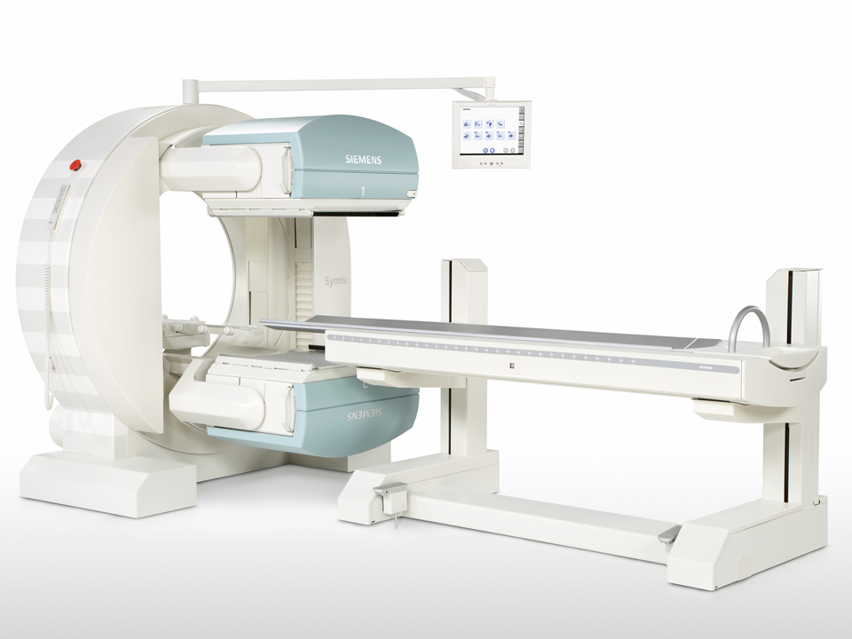

1. Dual Head Gamma Camera (Siemens-Symbia E) with SPECT
2. Biograph 6 Siemens PET-CT Scanner
3. Radio Iodine High dose Therapy ward facility.

**GAMMA CAMERA PATIENT SERVICES:**

**(**Dual head Gamma Camera (Siemens-Symbia E) with SPECT).

1.      99mTc - Bone Scan

2.      99mTc - DTPA Renography

3.      99mTc -DMSA cortical Renography

4.      99mTc -Thyroid Scintigraphy

5.      99mTc -MIBI Parathyroid

6.      99mTc -RBC Study (GI Bleed)

7.      99mTc - Esophageal Transit Time Study

8.      99mTc - Lung Perfusion Scan

9.      99mTc - Lympho scintigraphy

10.  99mTc -Meckles Diverticulum Study

11.  99mTc - Parotid Scintigraphy

12.  99mTc - Rest RNV Study (MUGA Scintigraphy)

13.  99mTc - SPECT Cerebral perfusion Study

14.  99mTc -Testicular Scintigraphy

15.  99mTc - Hynictoc Scintigraphy

16.  99mTc - Dacryo scintigraphy

17.  99mTc - Myocardial Stress Study

18.  99mTc - GE Reflux Study

19.  99mTc - Captopril Renogram

20.  99mTc- Hepatobiliary Scintigraphy

21.  131I - MIBG

22.  131I- Whole body Scan

23.  Post 131I- High Dose Therapy Scan

**PET-CT SERVICES:  (**Biograph 6 Siemens PET-CT Scanner)

1.      18-F FDG Whole body PET-CT Scan

2.      18-F PSMA Whole Body PET-CT Scan

3.      18F-Bone Scan

4.      F-18 FDG Brain Scan PET

**RADIONUCLIDE THERAPY WARD FACILITY**:

1.      131I - Low Dose Therapy for Thyrotoxicosis.

2.      131I - High Dose Therapy for differentiated thyroid carcinoma patients.

3.      153Sm/ 177-Lu- Bone pain Palliative Therapy

4.      Sm P-32 Colloid Radiosynovectomy

5.      Lu-177 DOTATATE Therapy

6.      Lu-177 PSMA Therapy

**2.7 CRITICAL CARE:**

**Blood Gas Analyser:**

Sensitive electrode used to measure specific blood gas components like

* K+ (potassium ion concentration),
* cNa+,
* cCa2,
* cCl-
* Metabolites: cGlu (glucose), cLac (lactate), ctBil (total bilirubin ) .

The electrode compares a potential developed at the electrode tip with a reference potential, the resulting voltage is proportional to the concentration of ions.

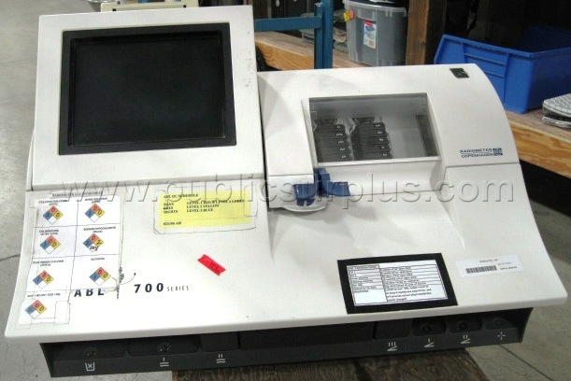

5.Fig. :Aerial blood gas analyser

*(PC-https://www.hilditchgroup.com/en/Lots/LotDetails/a80a5cd1-e2c7-aa42-95ac-6a2da4b5bcf7)*

Manufacturer: **RADIOMETER COPENHAGEN ABL 250**

Mechanical components:

Display/motherboard, electrode sensors, blood flow tubing’s, electrode, syringe injector. etc

Display settings:

Error log ,config settings, maintenance settings, alarm setting, etc

**Ventilator:**

A medical ventilator (or simply ventilator in context) is a machine designed to provide [mechanical ventilation](https://en.wikipedia.org/wiki/Mechanical_ventilation) by moving breathable air into and out of the lungs, to deliver breaths to a patient who is physically unable to breathe, or breathing insufficiently.

While modern ventilators are computerized machines, patients can be ventilated with a simple, hand-operated [bag valve mask](https://en.wikipedia.org/wiki/Bag_valve_mask).

Ventilators are chiefly used in [intensive care medicine](https://en.wikipedia.org/wiki/Intensive_care_medicine), [home care](https://en.wikipedia.org/wiki/Home_care), and [emergency medicine](https://en.wikipedia.org/wiki/Emergency_medicine) (as standalone units) and in [anaesthesiology](https://en.wikipedia.org/wiki/Anesthesiology) (as a component of an anaesthesia).

Medical ventilators are sometimes colloquially called "[respirators](https://en.wikipedia.org/wiki/Respirator)", a term stemming from commonly used devices in the 1950s (particularly the "[Bird Respirator](https://en.wikipedia.org/wiki/Forrest_Bird)"). However, in modern hospital and medical terminology, these machines are never referred to as respirators, and use of "respirator" in this context is now a deprecated anachronism signalling technical unfamiliarity. In the present-day medical field, the word "respirator" refers to a protective face mask.

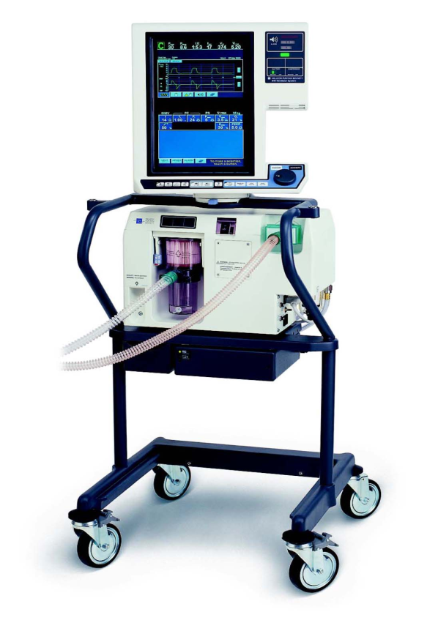

6.Fig. : Ventilator

*(PC-https://www.indiamart.com/proddetail/covidien-puritan-bennett-840-icu-medical-ventilator-pb-840-20621267048.html)*

Manufacturer: **PURIAN BENETT,840**

Controls: vent setup/alarm setup/sensor enabled.

modes:

* Assist control mode(VC/PC)
* SIMV mode(VC/PC)(bilevel)
* CPAP mode(VC/PC)
* Ventilation to patient(types):
* Invasive and non-invasive

Mechanical components:

* Display/motherboard
* Filter/air blender
* Oxygen sensors/control knobs
* Patient tubing’s etc

**Syringe pump:**

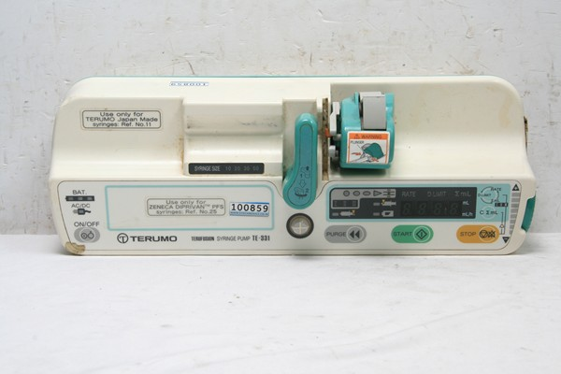

7.Fig. : Syringe pump

*(PC-https://www.dotmed.com/listing/pump-iv-infusion/terumo/331-syringe-pump/1169067)*

Manufacturer: **terumo te(ss700/800), termo te(331/332),I nfectomat agilia(fersenius kabi)**

Parts: Mother board, power supply, occulsion sensor, motor, syringe range sensor, etc

Display: rate of diffuse, alarm alerts, modes, etc

**Infusion pump:**

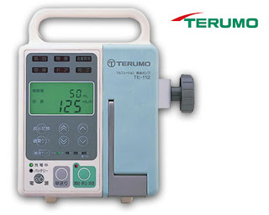

8.Fig. : Infusion pump:

*(PC- http://infusionpumpprice.blogspot.com/2016/05/infusion-pump-terumo-te-112-made-in.html)*

Manufacturer : F**ersinius optima,termo te 112**

Parts: Mother board, power supply, occulsion sensor, stepper motor, transformer, battery backup, airflow sensor, mode change switch etc

Display: Rate of drip,

Drip Adjustments,

drop adjust,alarm,power

Switch

Etc.

**Multipara monitor:**

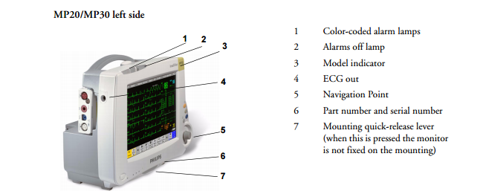

9.Fig. : Multipara monitor:

*(PC-https://www.medicalexpo.com/prod/philips-healthcare/product-70721-625087.html)*

Manufacturer: **Philip intellivue mx**

Parts: On/Standby Switch, Power and battery, Alarm lamp, Battery eject button, Hard keys ,Measurement connectors etc

Display:

Sensed output, alarms, config option, meno options,etc

**2.8 GENERAL SURGERY:**

The Department of General Surgery uphold a multi-faceted mission – it provides superior patient care and specialized focus in the field of laproscopy, and endoscopic procedures. The Department examines over 650 patients each year. It performs about 8500 major and 650 minor operations every year.

General surgery is a [surgical](https://en.wikipedia.org/wiki/Surgery) specialty that focuses on [abdominal](https://en.wikipedia.org/wiki/Abdomen) contents including [oesophagus](https://en.wikipedia.org/wiki/Esophagus), [stomach](https://en.wikipedia.org/wiki/Stomach), [small intestine](https://en.wikipedia.org/wiki/Small_intestine), [large intestine](https://en.wikipedia.org/wiki/Large_intestine), [liver](https://en.wikipedia.org/wiki/Liver), [pancreas](https://en.wikipedia.org/wiki/Pancreas), [gallbladder](https://en.wikipedia.org/wiki/Gallbladder), [appendix](https://en.wikipedia.org/wiki/Appendix_(anatomy)) and [bile ducts](https://en.wikipedia.org/wiki/Bile_duct), and often the [thyroid](https://en.wikipedia.org/wiki/Thyroid) gland (depending on local referral patterns).

They also deal with diseases involving the [skin](https://en.wikipedia.org/wiki/Human_skin), [breast](https://en.wikipedia.org/wiki/Breast), [soft tissue](https://en.wikipedia.org/wiki/Soft_tissue), [trauma](https://en.wikipedia.org/wiki/Trauma_(medicine)), [peripheral](https://en.wikipedia.org/wiki/Peripheral) [vascular surgery](https://en.wikipedia.org/wiki/Vascular_surgery) and [hernias](https://en.wikipedia.org/wiki/Hernia) and perform endoscopic procedures such as [gastroscopy](https://en.wikipedia.org/wiki/Gastroscopy) and [colonoscopy](https://en.wikipedia.org/wiki/Colonoscopy).

Surgical instruments can vary widely by the field of surgery that they are used in. In general instruments can be divided into five classes by function:

1. Cutting and dissecting instruments:
   * Scalpels, scissors, and saws are the most traditional
   * Although the term dissection is broad energy devices such as diathermy/cautery are often used as more modern alternatives.
2. Grasping or holding instruments:
   * Classically this included forceps and clamps predominately
   * Roughly forceps can be divided in traumatic (tissue crushing) and atraumatic (tissue preserving, such as Debakey's)
   * Numerous examples are available for different purposes by field
3. Haemostatic instruments:
   * This includes instruments utilized for the cessation of bleeding
   * Artery forceps are a classic example in which bleeding is halted by direct clamping of a vessel
   * Sutures are often used, aided by a needle holder
   * Cautery and related instruments are used with increasing frequency in high resource countries
4. Retractors:
   * Surgery is often considered to be largely about exposure
   * A multitude of retractors exist to aid in exposing the bodies cavities accessed during surgery
   * These can broadly be hand held (often by a junior assistant) or self-retaining
5. Tissue unifying instruments and materials:
   * This would include instruments that aid in tissue unification (such as needle holders or staple applicators)
   * And the materials themselves (sutures, staples, glue etc)

**2.9 GYNAECOLOGY:**

**Equipment**

 Below Equipment consist in OBGOT Open Instruments

* Abdominal Hysterectomy Sets -06
* Vaginal Hysterectomy Sets – 06
* Cervical Re-exploration Sets – 06
* LSCS Sets – 10
* Tubectomy Sets – 10
* Tuboplasty Sets – 10
* Hydrotubation Set – 01
* D & C Set – 01
* Mayomectomy Set  - 01

Laparoscopic Sets:

* Operating Laparoscopic Sets – 03
* Double Puncture Set – 01
* Diagnostic Lap.Hysterectomy Set – 01

   OBS Ward –Instruments list of Labour Room:

* Delivery Sets – 30
* D & C Sets- 03
* Suture Removal Sets – 13
* IUCD Insertion and Removal Set – 08
* LSCS Sets – 03
* Braun Decapitation hook – 02
* Novak Endometrial Biopsy Curatters – 03
* Mathew Dungon Dilators Sets – 02
* Hegars Dilators - 01

**Foetal Monitor:**

Foetal monitors are bedside units that consist of a monitoring unit, cables, and electrodes. They are designed to measure, record, and display FHR, uterine contractions, and/or maternal blood pressure and heart rate before and during childbirth.

These monitors may sense FHR and uterine contraction indirectly through the mother’s abdomen and/or directly by placing an electrode on the fetal scalp (or other exposed skin surface) and measuring the change in pressure within the uterus.

Antepartum fetal monitors are typically used in physician’s offices and clinics long before the beginning of labor. Most hospital-based monitors have additional capabilities, including fetal and maternal ECG recording.

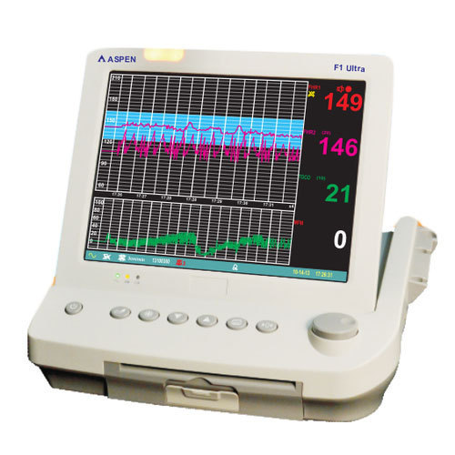

10.Fig. :Fetal Monitor

*(PC-https://www.indiamart.com/proddetail/f1-ultra-fetal-monitor-19218515433.html)*

**Principles of operation:**

Fetal monitors detect FHR externally by using an ultrasound transducer to transmit and receive ultrasonic waves; the frequency (or Doppler) shift of the reflected signal is proportional to the velocity of the reflecting structure—in this case, the fetal heart.

A transducer contains one or more piezoelectric elements that convert an electrical signal into ultrasonic energy that can be transmitted into tissues. When this ultrasonic energy is reflected back from the tissues, the transducer reconverts it to an electrical signal that can be used to create a waveform for display and recording and an audible FHR (sound created by the frequency shift of the ultrasonic signal).

Requirements: Uninterruptible power source, battery backup, appropriate transducer/ electrodes/sensors

Approx. dimensions (mm): 100 x 150 x 200

Approx. weight (kg): 6

Consumables: Batteries, cables, electrodes/ sensors, gel

Typical product life time (years): 8 Shelf life (consumables): NA

**OB/GYN Table:**

Manufacturer: Clinton Industries 8870 OB GYN Exam Table

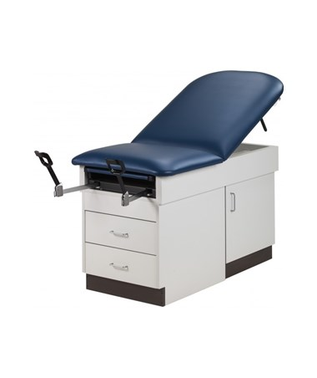

11.Fig. :OB/GYN Table

*(PC:https://www.tigermedical.com/Products/OB-GYN-Exam-Table__CLI8870OBGYN.aspx)*

Product Highlights:

* Weight capacity: 400 lbs
* Dimensions: 58/72" L x 28.5" Wx 31" H
* Uniquely suited for the OB GYN practice
* Chip-resistant laminate base; CA CARB II compliant
* Accessible, convenient storage space
* Pneumatic adjustable backrest
* 3-year warranty
* Dozens of custom colour combinations available

**2.10 PAEDIATRICS:**

**Cardiotoco Meter:**

Cardiotocography (CTG) is a technical method for recording (-graphy) the foetal heartbeat using ultrasound (cardio-) and the uterine contractions (-toco-) during pregnancy, typically in the third trimester. The machine which is used to perform the monitoring is called a cardiotocograph, commonly known as a foetal monitor.

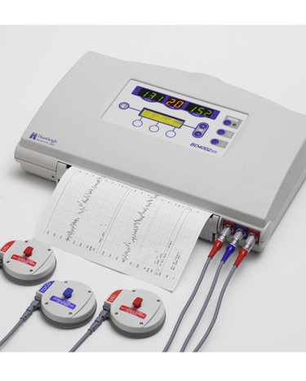

12.Fig. : Cardiotoco Meter

*(PC-http://www.huntleigh-diagnostics.com/store/obstetric-monitoring/sonicaid-fetal-monitoring/fetal-monitors/sonicaid-bd4000xs-fetal-monitoring)*

Model Name: **Huntleigh BD400 AXS**

**Uses**:

* The aim is to identify babies who may be short of oxygen (hypoxic).
* Assessments of foetal well-being
* The baby delivered by caesarean section or instrumental vaginal birth.

**Troubleshooting:**

* problem in FHR and Toco transducer
* Failure in event marker switch

**Infant Warmer:**

Warmer are used to maintain the body temperature of new-born infants

Warmer should be maintained 38⁰ c and should be kept 85-90cm distance from IR to cradle

Thermistor probe constantly connected with the infant to monitor temperature of the infant.

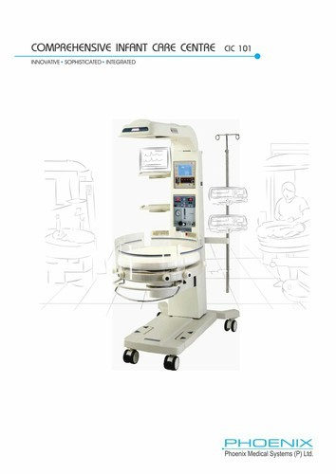

13.Fig. :Infant Warmer

*(PC-https://www.indiamart.com/proddetail/phoenix-cic-101-radiant-heat-warmer-19924387130.html)*

MODEL NAME: **Phoenix**

**2.11 NEUROLOGY:**

The Department deals with clinical, teaching & research activities. The Department runs regular outpatients on all days i.e., from Monday to Saturday and special clinics for epilepsy on every 3rd Sunday. The department runs 24 hours emergency services which includes inpatients and neuro-emergency cases in Casualty which accounts for 40% of all emergencies in the institute. Active clinical and research activities in the field of stroke and epilepsy patients being established.

**Equipment**

1.      Video Digital EEG 128 channel   : Galileo Company

2.      Video Digital EEG 40 channel     : Galileo Company : 2 nos

3.      ENMG 10 channel                        : Medelec Company

4.      ENMG 10 channel                        : Natus Company

5.      Magnetic Stimulator Machine       : Hospi – Media Company

**Electroencephalography (EEG):**

It is an [electrophysiological](https://en.wikipedia.org/wiki/Electrophysiology) monitoring method to record electrical activity of the [brain](https://en.wikipedia.org/wiki/Brain). It is typically non-invasive, with the [electrodes](https://en.wikipedia.org/wiki/Electrode) placed along the [scalp](https://en.wikipedia.org/wiki/Scalp), although invasive electrodes are sometimes used, as in [electrocorticography](https://en.wikipedia.org/wiki/Electrocorticography). EEG measures voltage fluctuations resulting from [ionic current](https://en.wikipedia.org/wiki/Ion_current) within the [neurons](https://en.wikipedia.org/wiki/Neurons) of the [brain](https://en.wikipedia.org/wiki/Brain).

Clinically, EEG refers to the recording of the brain's spontaneous electrical activity over a period of time, as recorded from multiple [electrodes](https://en.wikipedia.org/wiki/Electrode) placed on the scalp.

Diagnostic applications generally focus either on [event-related potentials](https://en.wikipedia.org/wiki/Event-related_potential) or on the [spectral content](https://en.wikipedia.org/wiki/Frequency_spectrum) of EEG. The former investigates potential fluctuations time locked to an event, such as 'stimulus onset' or 'button press'.

The latter analyses the type of [neural oscillations](https://en.wikipedia.org/wiki/Neural_oscillation) (popularly called "brain waves") that can be observed in EEG signals in the frequency domain. EEG is most often used to diagnose [epilepsy](https://en.wikipedia.org/wiki/Epilepsy), which causes abnormalities in EEG readings.

It is also used to diagnose [sleep disorders](https://en.wikipedia.org/wiki/Sleep_disorder), depth of anaesthesia [coma](https://en.wikipedia.org/wiki/Coma), [encephalopathies](https://en.wikipedia.org/wiki/Encephalopathies), and [brain death](https://en.wikipedia.org/wiki/Brain_death). EEG used to be a first-line method of diagnosis for [tumours](https://en.wikipedia.org/wiki/Tumor), [stroke](https://en.wikipedia.org/wiki/Stroke) and other focal brain disorders, but this use has decreased with the advent of high-resolution anatomical imaging techniques such as [magnetic resonance imaging](https://en.wikipedia.org/wiki/Magnetic_resonance_imaging) (MRI) and [computed tomography](https://en.wikipedia.org/wiki/Computed_tomography) (CT).

Despite limited spatial resolution, EEG continues to be a valuable tool for research and diagnosis. It is one of the few mobile techniques available and offers millisecond-range temporal resolution which is not possible with CT, PET or MRI.

Derivatives of the EEG technique include [evoked potentials](https://en.wikipedia.org/wiki/Evoked_potential) (EP), which involves averaging the EEG activity time-locked to the presentation of a stimulus of some sort (visual, [somatosensory](https://en.wikipedia.org/wiki/Somatosensory), or auditory).

[Event-related potentials](https://en.wikipedia.org/wiki/Event-related_potentials) (ERPs) refer to averaged EEG responses that are time-locked to more complex processing of stimuli; this technique is used in [cognitive science](https://en.wikipedia.org/wiki/Cognitive_science), [cognitive psychology](https://en.wikipedia.org/wiki/Cognitive_psychology), and [psychophysiological](https://en.wikipedia.org/wiki/Psychophysiology) research.

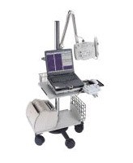

14.Fig. : EEG

*(PC-https://www.medwrench.com/equipment/2250/medelec-teca-emg-ep-plinth-system-n)*

Manufacturer: ENMG 10 channel: Medelec Company

EEG appliance records brain waves. The displayed digital EEG system is on PC. It features 32-channel 100MΩ junction box with 32-channel digital pre-amplifier; LED to check impedance and leads, filters, patient event marker; stand for the accessory box; isolation transformer; digital processing signal.

**Electromyography** (**EMG**):

It is an [electrodiagnostic medicine](https://en.wikipedia.org/wiki/Electrodiagnostic_medicine) technique for evaluating and recording the electrical activity produced by [skeletal muscles](https://en.wikipedia.org/wiki/Skeletal_muscles). EMG is performed using an [instrument](https://en.wikipedia.org/wiki/Medical_instrument) called an electromyograph to produce a record called an electromyogram.

An electromyograph detects the [electric potential](https://en.wikipedia.org/wiki/Electric_potential) generated by muscle [cells](https://en.wikipedia.org/wiki/Cell_(biology)) when these cells are electrically or neurologically activated.

The signals can be analysed to detect medical abnormalities, activation level, or recruitment order, or to analyse the [biomechanics](https://en.wikipedia.org/wiki/Biomechanics) of human or animal movement.

Manufacturer: **Nicolet EDX EMG / NCS / EP / IOM**

It is the industry-leading electrodiagnostic system used to measure nerve and muscle function and can also provide intraoperative monitoring for the operating room. The Nicolet EDX is powered by Viking® or Synergy Software with a variety of study/exam options providing fast and efficient workflow.

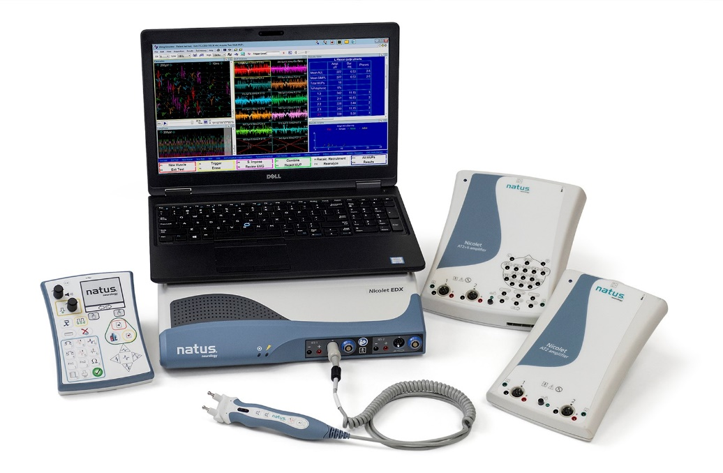

15.Fig. : EMG

*(PC-https://neuro.natus.com/products-services/electromyography-emg-solutions)*

This hardware/software platform combines a familiar clinical workflow and user interface to provide innovative features developed to reduce artifacts, reduce operator errors, and improve ease of use. Viking Software not only provides exceptional quality electrodiagnostic studies for routine examinations, but also for challenging cases in difficult clinical environments, even including in the operating room for IOM studies.

**Key Features:**

* Efficient clinical workflow from patient entry to report
* Advanced technology amplifiers with high resolution signals
* Two amplifier options provide basic or advanced EMG / NCS / EP testing
* Comfortable, ergonomic electrical stimulator probes
* Two trustworthy user interfaces: Viking or Synergy
* Integrated SQL database with networked access and data review
* HL7® Gateway and advanced connectivity
* Citrix® compatibility providing remote access from anywhere
* 16-channel clinical EP/IOM amplifier option

**2.12 OPTHALMOLOGY:**

**Diathermy machine:**

Diathermy machine provides appropriate power for cutting, coagulation and blending in monopolar and bipolar mode.

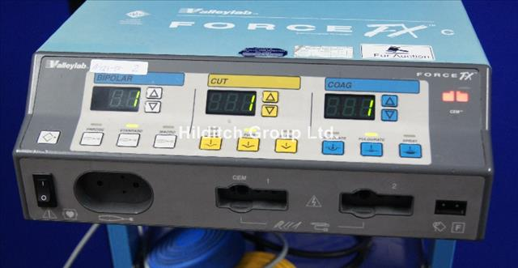

16.Fig. :Diathermy Machine

*(PC- https://auctions.britishmedicalauctions.co.uk/lot-details)*

Manufacturer: **Valley lab**

Model: **force fx 8c**

High frequency of current is discharged at the end of the probe produces high heat that cuts the tissues.

Diathermy uses 2khz to 3khz so that it does not produce shock to the body.

Instant response technology

Three bipolar modes: precise, standard, macro

Three monopolar cut mode: low, pure and blend.

Three monopolar coagulation mode: low, medium, high.

Supports for simultaneous coagulation.

**Components:**

Front panel components

Power switch

Receptacle for connecting

Indicator that alerts

Rear panel components:

Volume control

Footswitch receptacle

Power entry module

Three ports

Internal components:

* control board
* display board
* footswitch board
* power supply board

**2.13 BIOCHEMISTRY LAB:**

Monitoring of laboratory quality is done through general laboratory maintenance, proper selection of equipment, methods and their valuation and internal quality control by way of  two levels of quality control material run daily along with the  generation of  quality control charts every month. Apart from this, the results are scrutinized by experienced and qualified medical experts in the field before they are reported.

EQUIPMENT:

|  |  |  |
| --- | --- | --- |
| **Name** | **Make** | **Serial Number** |
| Access-2 Immunoassay Analyzer | Beckman | 570682 |
| ABG Analyzer | Radiometer | 754R25BN006 |
| Analyzer Na, K.(EX-DS) | SM Diagnostics | 170291547 |
| Auto Analyzer AU 480 | Beckman | 2018041921 |
| RO Water System | Aster | TDSCL550 |
| Auto Analyzer Bio-ISE Chemwell | CPC | 29102243 |
| PCR | Eppendorf | 409156 |
| Gel documentation | Bioscreen | 511275 |
| HPLC | Shimadzu |  |
| Laminar Airflow | Technico |  |
| Automated elisa system | Euroimmun | 628000310 |
| Elisa reader | Erba | 161027 |
| Elisa Washer | Erba | 131334 |
| Biophotometer (Nanodrop) | Eppendorf | F0201402 |
| Transilluminator | Labmate | 111146 |
| UV Spectrophotometer-25 | Perkin Elimer | 30206 |
| spectrophotometer-118 | Systronic | 1807 |
| Semi auto Analyzer | Stat Fax CPC | 3422 |
| Osmometer | Gonotec | 130413 |
| Hot Air sterilizer | Heco | 102 |
| Hot Air Oven | Kemi | 15076 |
| Incubator digital | Heco | 10 |
| Vertical auto clave | Equitron | 7440F |
| Flame Photometer | Elico | 2531 |
| Double Distiller | Bhanu | 6210904034 |
| Ultrasonic Cleaner | Torsin | 020 |
| Colorimeter | Elico | 5147 |
| Water bath with Shaker | Remi | 1070 |
| Rotary shaker Mini | Remi | 976 |
| Homogenizer | Remi | 4562 |
| Rotating Circular Cell Mixer | Neolab | 245236 |
| Analytical balance | Sartorius | 30102467 |
| Electronic compact Balance | citizen | 201702/303 |
| Balance Open | Braun | X |
| Ref centrifuge-MC24 | Remi | VCDT5677 |
| Vertical Autoclave | Chemi | 2619 |
| Centrifuge R8C | Remi | 2765 |
| Cyclomixer | Remi | 1245 |
| PH meter | Elico | 1889 |
| Hot plate | kemi | 3438 |
| Hot plate mag stirror | Stuart | 15379 |
| Power supply electrophorosis | Genei | F10020 |
| SDS Page | Genei | 807 |
| Weighing machine personal | Libra | 67030 |
| Vacuum pump with HPLC kit |  |  |
| Deep freezer (-86) | Forma sci | 817306-769 |
| Refrigerator | Whirlpool | 65 |
| Split AC 2tun | Lloyd |  |
| Centrifuge | Remi | 3408 |
| Hotplate SS Top | Guna | 5011 |

**Coagulation analyser:**

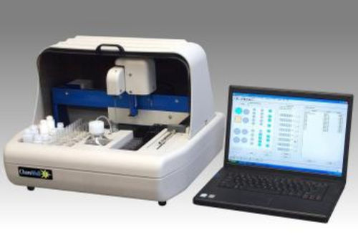

17.Fig. : Coagulation analyser

*(PC-https://www.medicalexpo.com/prod/awareness-technology/product-67695-431575.html)*

Manufacturer: Auto Analyzer Bio-ISE Chemwell

Parts: sample drawer, reagent drawer, peltier, measurement area, incubator, heat radiator, vacuum pump, harddisk, photo metric module.

Principle: viscosity based detection

Display: Sensed output, alarms, config options,etc

**Auto analyser:**

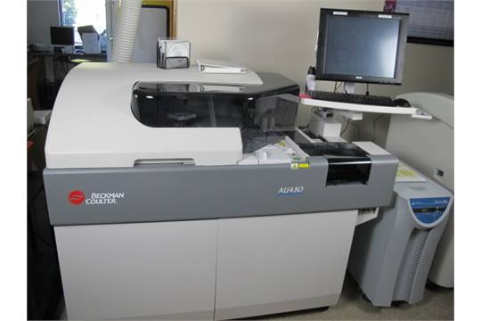

18.Fig. : Auto analyser:

*(PC-https://www.bidspotter.com/en-us/auction-catalogues/bscsal/catalogue-id-bscsal10021/lot-5a543249-9a70-4eda-9e77-a3c500ea62ac)*

Manufacturer : Auto Analyzer AU 480

Parts:R1, R2 reagent arm , Reagent cartridge tray, Computer hard drive, Cuvette manufacturing area , System control boards, Segmented sample area ,Cuvette film cartridge , Photometric sample probe, Sample, reagent pumps, probe cleaner pumps etc

Display: output display, mode configuration options, user interface etc

**Biorefrigrator:**

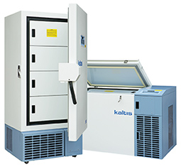

19.Fig. 12: Biorefrigrator

*(PC-https://www.indiamart.com/proddetail/lab-refrigerator-bio-ultra-21885448791.html)*

Manufacturer: **kaltis**

Parts: refrigerating unit, compressor unit, power supply unit, etc

Display: voltage graph, temperature adjustment display

**Microscope:**

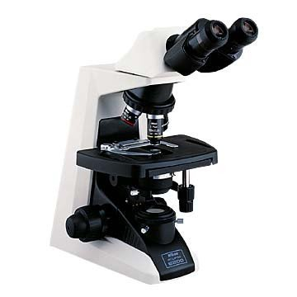

20.Fig. : Microscope

*(PC-https://www.indiamart.com/proddetail/nikon-microscope-e-200-16513468530.html)*

Manufacturer : **Nikon**

Parts:10x,20 x lens, condenser, diaphragm, coarse focus, fine focus knobs, luminous supply, power supply, magnifier, mechanical stage, ocular stage, objective lens etc

**2.14 OPERATION THEATRE (O.T):**

An operating theatre (also known as an operating room (OR), operating suite, or operation suite) is a facility within a [hospital](https://en.wikipedia.org/wiki/Hospital) where surgical operations are carried out in an [aseptic](https://en.wikipedia.org/wiki/Asepsis) environment.

Historically, the term "operating theatre" referred to a non-sterile, tiered [theatre](https://en.wikipedia.org/wiki/Theater_(building)) or [amphitheatre](https://en.wikipedia.org/wiki/Amphitheater) in which students and other spectators could watch surgeons perform surgery.

Contemporary operating rooms are devoid of a theatre setting, making the term "operating theatre" a misnomer. There are only two old-style operating theatres left, both of which are preserved as part of museums.

**OT Light:**

A surgical light also referred to as an operating light or surgical light head is a medical device intended to assist medical personnel during a surgical procedure by illuminating a local area or cavity of the patient.

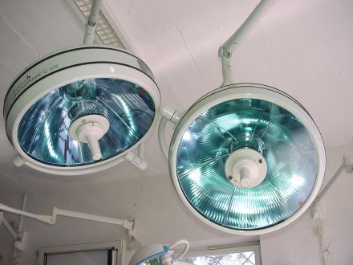

21.Fig. : OT Light

*(PC-http://www.medwow.com/med/surgical-light/berchtold/chromophare-c-572/17649.model-spec)*

Manufacturer & Model : **simled 5000,simled 7000,Berchtold chromopare 572.**

Types :

* 2 Dhoom
* 3 Dhoom
* LED

Light intensity mesured in LUX.

1 LUX = 1000 candle light power.

2Dhoom light = 1,40,000 lux power

3Dhoom light = 1,60,000 lux power

**Equipment:**

**1. Utility Columns**

Utility columns accommodate a variety of OR-administered services, ensuring [better management of workspace](https://www.meditek.ca/services/design-space-planning/) in an OR.

The columns can also be retractable or fixed and provide a viable solution for the distribution of communication units, electrical services and medical gases in OR suites.

With utility columns, surgeons can access electrical devices that are pre-wired, along with medical gas outlets that include a single point connection at the top of the unit.

The columns can even be integrated with a CO2or nitrogen control panel to help surgeons deliver better patient support.Utility columns can be raised or lowered with ease.

When a utility column is raised, it provides additional space; when the column is lowered, it ensures that surgeons can hook up to various OR-administered services immediately.

**2. Surgical and Exam Lights**

Operating on a patient is challenging, and surgical lights empower medical professionals to work to the best of their ability.

Picking top-of-the-line surgical and exam lights ensure these professionals can enjoy the benefits of working in a well-lit OR at all times.

Many diverse surgical and exam lights currently are available, including:

* **Ceiling-mounted surgical lights**: [Ceiling-mounted LED and halogen lights](https://www.meditek.ca/products-page/ceiling-mounted/) are among the top options available to brighten your OR.
* **Mobile surgical lights**: Is your OR in transition? In a temporary room, or for a short-term solution, you simply cannot go wrong with mobile lights. [Mobile surgical lights](https://www.meditek.ca/products-page/surgical-lights/mobile/) are bright and powerful, providing the ideal combination for just about any OR.
* **Surgical headlights**: Light, bright and comfortable, [surgical headlights](https://www.meditek.ca/products-page/surgical-lights/headlights/) provide surgeons with extra illumination right at the spot they are investigating. These headlights are lightweight and comfortable and will illuminate just about any space immediately.

Adding first-rate **surgical and exam lights** is necessary for an OR, regardless of a hospital’s size.

With these lights at your disposal, you’ll be better equipped to maintain a secure, productive work environment.

**3. Stretchers and Stretcher Accessories**

You’ll be able to do so quickly and effortlessly if you deploy [first-rate patient transfer stretchers for your OR](https://www.meditek.ca/products-page/meditek-stretchers/qa3-patient-transport-stretchers/).

Hospital stretchers are crucial for various surgical procedures, such as ophthalmologic, bariatric and paediatric.

They are designed to help patients remain comfortable and accessible. Stretcher accessories can customize a patient transport stretcher into a specific use stretcher.

For example, MediaTek manufactured a **paediatric enclosure** accessory for its line of QA3 stretchers, making the QA3 ideal for children with the combination of the enclosure keeping them safe and the stretcher’s **lowest height ability.**

**4. Cushions and Mattresses**

Whenever a new patient arrives, you’ll want to be ready to ensure that he or she can receive support in a plush or firm bed.

Many [cushions and mattresses](https://www.meditek.ca/products-page/surgical-table-cushions/) are available that are designed to assist patients of all ages and sizes.

Mattresses and cushions can be purchased as complete sets or as separate leg, head, or body cushions.

Two of the most common surgical table cushions include:

* **Standard Surgical Table Pads** – As electrically conductive cushions, standard surgical table pads feature a supportive urethane core and Lectrolite covering that is simple to clean. The cushions also can help patients avoid bedsores and are ideal for patients during shorter medical procedures.
* **Premium Sof-Care Deluxe Surgical Table Pads**– For superior pressure management and enhanced positioning capabilities, the Premium Sof-Care Deluxe surgical table pads represent great options. The surgical table pads feature an electrically conductive four-way anti-stretch cover for increased durability, fluid-resistant seams to reduce the risk of cross-contamination, and other features that make the table pads valuable in an OR.

Selecting the right cushions and mattresses – and ensuring they are available to patients every day – is crucial.

With a dependable supplier of bedding at your side, you should have no trouble finding the ideal padding for your OR.

**5. Space Management Booms**

An everyday OR can become a stressful place to work if there is limited space. In fact, stress remains an ongoing problem among OR personnel, which is reflected in recent data.

A study of OR personnel published by the Thrita medical journal indicated 48 percent of nurses said they experienced “work overload” that led to increased stress levels.

Also, the study revealed OR technicians usually experienced higher stress levels than other OR personnel.Physical environment factors can affect a medical professional’s stress levels.

Comparatively, [space management booms](https://www.meditek.ca/products-page/space-management-booms-equipment-carriers/) may help medical personnel conserve space, increase their productivity, and minimize their stress levels simultaneously.

Space management booms can added to almost any OR, regardless of size, and enable medical professionals to make the most of the available space in this room.

**6. Sterilization and Cleaning Equipment**

No one wants to put themselves or their patients at risk of infection, and [sterilization and cleaning equipment](https://www.meditek.ca/products-page/sterilization-cleaning/) is available that can make a world of difference for OR personnel and their patients.

To better understand the importance of sterilization and cleaning equipment in ORs, let’s consider the results of a recent study on OR foot traffic conducted by Orthopaedics.

The study, which examined “the number and length of door openings during nearly 200 knee and hip arthroplasty surgeries performed at Johns Hopkins Bayview Medical Centre over three months,” showed excessive door openings and foot traffic could put OR personnel and their patients at greater risk of infection.

Study researchers found that OR doors were surgeries. These open doors commonly defeated the purpose of many safety tactics that medical personnel used to keep ORs germ- and contamination-free, according to study researchers.

“Our findings add to a growing body of evidence of a relatively common practice that could be a potential safety concern and raises questions about why doors get opened and how we can prevent or minimize the frequency and duration of behaviours that could compromise OR sterility,” study senior author Stephen Belkoff, Ph.D., said in a prepared statement. “We know for sure is that there was a whole lot more traffic in and out of the OR than seems necessary or easily explained.”

Sterilization and cleaning equipment, on the other hand, enables OR personnel to devote the necessary time and resources to maintain pristine work environments.

This equipment allows medical professionals to protect themselves and their patients against a wide range of potential hazards, such as hospital acquired infections.

**7. Disposables and Consumables**

Facemasks and other disposables and consumables help safeguard an OR surgeon as well as team members and patients consistently.

Many top-of-the-line [disposables and consumables](https://www.meditek.ca/products-page/disposables-consumables/) such as biohazard bags, patient care gloves, and waterproofing pads are available and designed for single use.

That way, after you are finished using a single disposable or consumable item, you’ll be able to replace it for the next patient to improve your chances of maintaining a safe work environment.

**8. Gel Pads and Positioners**

Imagine what it would be like to provide patients with unparalleled support to help them combat general pain and soreness.

Thanks to gel pads and positioners, you’ll be able to do just that, as these items enable a patient to sit or rest comfortably and avoid skin or tissue damage.

[Gel pads and positioners](https://www.meditek.ca/products-page/gel-pads-positioners/) typically offer a number of benefits for patients, including:

* Can be heated or cooled instantly.
* Repairable and reusable for long-lasting value.
* Can’t be affected by body fluids, and are easy to clean.
* Serve as cost-effective options, making them great choices for hospitals of all sizes.
* Leakproof, guaranteeing you won’t have to worry about each product’s interior spilling out.

**9. Surgical Tables and Surgical Table Accessories**

A high quality surgical table and surgical table accessories are at the core of ensuring your OR team can perform the surgery at hand with confidence.

[Surgical tables](https://www.meditek.ca/products-page/surgical-tables/) are valuable for surgeons during both open and minimally invasive procedures.

The tables are manufactured for general surgery, neurology procedures, and other OR applications.

Whether performing general or specialized surgeries, [surgical table accessories](https://www.meditek.ca/products/surgical-table-accessory/) will make either more efficient and comfortable for the patient.

A list of general and specific use accessories:

* Anaesthesia Screens
* Arm & Hand Surgery Tables
* Arm Supports
* Clamps
* Drain Pans, Hoops & Screens
* Head Supports
* Leg Supports
* Positioners
* Restraint Straps
* Side Extensions
* Transfer Boards

**10. Digital Integration Systems**

Digital integration systems give you a central point of control for all of the moving pieces in the OR.For instance, the [SkyVision SDS Digital Integration System](https://www.meditek.ca/products-page/skyvision-sds-integration-system/) remains a top choice for surgeons because it offers:

* **Ability to Connect with Up to 10 Sources** – Surgeons can transmit images to four displays at a time, and the system’s windowing features empower surgeons to streamline image management.
* **Simple to Use** – With a seven-button keyboard or touchscreen display, surgeons can manage image sources with ease.
* **Flexible Installation** – The system can be installed as part of an equipment boom, a nurse documentation centre or a nurse desk or mobile cart for added flexibility.

Moreover, cameras are available that capture with deluxe images.

These cameras can be positioned in a variety of ways and enable medical personnel to record sessions, conduct live broadcasts, and much more.The [Skytron Sony Room Camera PTZ](https://www.meditek.ca/products-page/cameras-digital-integration-systems/skytron-sony-room-camera-ptz/) serves as a valuable camera in many ORs, as it delivers a quality image that can be routed to multiple systems.

This camera also provides four position pre-sets, outstanding low light sensitivity, and other features that make it a superior option in an OR.

**2.15 RADIOLOGY:**

Radiology plays a vital role in determining the accuracy of diagnosis and the subsequent planning of treatment. The clarity and sophistication of the images help doctors and surgeons plan every aspect of surgery in advance. In other words, imaging is the ‘the visual inspection of internal organs without incision’.  
The radiology was well equipped with the state-of-art equipments such as 128 multislice CT scanner and another one is Spiral CT scanner, MRI (1.5 Tesla) The department is carrying out routinely interventional work under CT and ultra sound guidance like biopsies, drainages, PCN, embolisation of tumour vessels as well as balloon dilatation

|  |  |
| --- | --- |
| **EQUIPMENT NAME** | **COMPANY NAME** |
| Magnetic Resonance Imaging ( MRI ) | SIEMENS |
| Multi slice computerized tomography (MCT) | SIEMENS |
| Digital X – Ray | CANON |
| Flouroscopy | SIEMENS |
| 500 MA X- Ray | SIEMENS |
| 800 MA X – Ray | PHILIPS /PRORAD |
| 1000 MA X – Ray | LISTEM |
| Digital Mammography | SIEMENS |
| Analog Mammography | LILYEUM |
| Ultra sound / Doppler system | PHILIPS |
| Ultra sound / Doppler system | VOLUSION |
| Ultra sound / Doppler system – 1 | ESOATE |
| Ultra sound / Doppler system – 2 | ESOATE |
| Ultra sound / Doppler system – 3 | ESOATE |
| Ultra sound / Doppler system - 4 | ESOATE |
| Ultra sound system / Doppler | PHILIPS |
| CR Processing – OP | KODAK |
| CR Processing – IP | KODAK |
| BED SIDE X – Ray Machine – 1 | ALLENGERS |
| BED SIDE X – Ray Machine – 2 | ALLENGERS |
| BED SIDE X – Ray Machine – 3 | ALLENGERS |
| BED SIDE X – Ray Machine – 1 | ADONIS |
| BED SIDE X – Ray Machine – 2 | ADONIS |
| BED SIDE X – Ray Machine – 3 | ADONIS |
| BED SIDE X – Ray Machine – 4 | ADONIS |
| BED SIDE X – Ray Machine | SEIMENS’S |

**X-RAY:**

An X-ray generator is a device used to generate X-rays. It is commonly used by radiographers to acquire an x-ray image of the inside of an object (as in medicine or non-destructive testing).But they are also used in sterilization or fluorescence. They travel in straight lines. They are shorter wave length than visible light. Able to penetrate solid materials of varying densities.

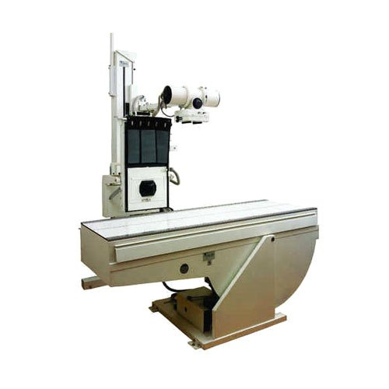

22.Fig. : X-RAY

*(PC-https://www.indiamart.com/proddetail/800ma-x-ray-machine-14338185391.html)*

MAKE: **SIMENS**

MODEL: **800 MA X-RAY**

Mainly there are two parameters that are to be varied to obtain x-rays I,e kV and mAs for penetration and contrast respectively.

Digital radiography or digital X-rays do not need any cassette rather they are replaced by detectors.

**MRI:**

MRI equipment combines computer technology, a magnetic field, and radio waves to produce a two-dimensional image of a “slice” of the patient’s anatomy.

This process is radiation free, and the radio waves are harmless. Unlike CT scans and x-ray images, MRI scans produce highly detailed images that are adept at identifying soft tissue pathologies.

Another advantage of MRI is that it can produce images in different anatomical planes, enabling study of the anatomy from different angles.

The MRI equipment consists of following components: The magnet generates the magnetic field. Shim coils make the magnetic field homogeneous. Radio frequency coils transmit the radio signal into the body part being imaged.

**CT:**

A CT scan or computed tomography scan (formerly computerized axial tomography scan or CAT scan) makes use of computer-processed combinations of many [X-ray](https://en.wikipedia.org/wiki/X-ray) measurements taken from different angles to produce cross-sectional ([tomographic](https://en.wikipedia.org/wiki/Tomography)) images (virtual "slices") of specific areas of a scanned object, allowing the user to see inside the object without cutting.

The 1979 [Nobel Prize in Physiology or Medicine](https://en.wikipedia.org/wiki/Nobel_Prize_in_Physiology_or_Medicine) was awarded jointly to [Allan M. Cormack](https://en.wikipedia.org/wiki/Allan_M._Cormack) and [Godfrey N. Hounsfield](https://en.wikipedia.org/wiki/Godfrey_N._Hounsfield) "for the development of computer assisted tomography."

[Digital geometry processing](https://en.wikipedia.org/wiki/Geometry_processing) is used to further generate a [three-dimensional](https://en.wikipedia.org/wiki/Three-dimensional_space) volume of the inside of the object from a small series of two-dimensional [radiographic](https://en.wikipedia.org/wiki/Radiography) images taken around a single [axis of rotation](https://en.wikipedia.org/wiki/Axis_of_rotation).

[Medical imaging](https://en.wikipedia.org/wiki/Medical_imaging) is the most common application of X-ray CT. Its cross-sectional images are used for [diagnostic](https://en.wikipedia.org/wiki/Diagnosis) and therapeutic purposes in various medical disciplines. The rest of this article discusses medical-imaging X-ray CT; industrial applications of X-ray CT are discussed at [industrial computed tomography scanning](https://en.wikipedia.org/wiki/Industrial_computed_tomography_scanning).

The term "computed tomography" (CT) is often used to refer to X-ray CT, because it is the most commonly known form. But, many other types of CT exist, such as [positron emission tomography](https://en.wikipedia.org/wiki/Positron_emission_tomography) (PET) and [single-photon emission computed tomography](https://en.wikipedia.org/wiki/Single-photon_emission_computed_tomography) (SPECT). X-ray tomography, a predecessor of CT, is one form of radiography, along with many other forms of tomographic and non-tomographic radiography.

CT produces data that can be manipulated in order to demonstrate various bodily structures based on their ability to absorb the X-ray beam. Although, historically, the images generated were in the axial or transverse [plane](https://en.wikipedia.org/wiki/Anatomical_plane), perpendicular to the long axis of the body, modern scanners allow this volume of data to be reformatted in various planes or even as volumetric (3D) representations of structures.

Although most common in medicine, CT is also used in other fields, such as [non-destructive materials testing](https://en.wikipedia.org/wiki/Nondestructive_testing). Another example is archaeological uses such as imaging the contents of sarcophagi or ceramics. Individuals responsible for performing CT exams are called [radiographers](https://en.wikipedia.org/wiki/Radiographers) or radiologic technologists.

Use of CT has increased dramatically over the last two decades in many countries. An estimated 72 million scans were performed in the United States in 2007 and more than 80 million a year in 2015.

One study estimated that as many as 0.4% of current cancers in the United States are due to CTs performed in the past and that this may increase to as high as 1.5 to 2% with 2007 rates of CT use; however, this estimate is disputed, as there is not a consensus about the existence of damage from low levels of radiation.

Lower radiation doses are often used in many areas, such as in the investigation of renal colic. Side effects from [intravenous contrast](https://en.wikipedia.org/wiki/Intravenous_contrast) used in some types of studies include the possibility of exacerbating [kidney problems](https://en.wikipedia.org/wiki/Kidney_problems) in the setting of pre-existing kidney disease.

**Gamma Camera:**

A gamma camera (γ-camera), also called a scintillation camera or Anger camera, is a device used to image gamma radiation emitting radioisotopes, a technique known as [scintigraphy](https://en.wikipedia.org/wiki/Scintigraphy).

The applications of scintigraphy include early drug development and [nuclear medical imaging](https://en.wikipedia.org/wiki/Nuclear_medicine) to view and analyse images of the human body or the distribution of medically injected, inhaled, or ingested [radionuclides](https://en.wikipedia.org/wiki/Radionuclides) emitting [gamma rays](https://en.wikipedia.org/wiki/Gamma_ray).

**2.16 PHYSIOTHERAPY:**

**Physical Therapy Clinic Exercise Equipment for Strength and Balance**

Regaining strength and balance is a critical part of any therapy program, and while calisthenics are used often in rehabilitation, many times machines are the only option. The equipment used were-

* Upright and Recumbent Bikes
* Standing Elliptical
* Rehab Treadmill
* Unweighing System
* Training Stairs
* SciFit Upper-Body Exerciser
* Cable Columns and Pulley System
* Power Plate
* Power Rack and Weight Bench
* Smith Machine
* Accessory Muscle Group Machines
* Rebounders: Round and Square
* Plyometric Sleds
* Recumbent Squat System
* Thera-Band Rehab and Wellness Station

**OUTCOME OF INTERNSHIP:**

The hospital training at SRI VENKATESHWARA INSTITUE OD MEDICAL SCIENCES, Tirupathi, was very interesting and informative where I was able to gain a lot of experience on how work is being done in a hospital. Being there, I had a wide range of exposure to various medical drug, medical equipment, and a lot more. I was also able to have an overall idea about the roles and duties of biomedical engineers in a hospital and their work in the maintenance of the equipment and functioning of the hospital.

**INTERN CERTIFICATE**

